1) Create a CIK code mapping for all company names and add additional field in indices table.
Done. The CIK codes are embedded in the Yahoo SEC+Filings link. I retrieved as many as possible and stored.

2) Create a table to store the filings. Symbol,FilingDate,FilingForm,FilingContent
Pending

2) In order to get the filings...use the cik code for a given company.

http://www.sec.gov/cgi-bin/browse-edgar?action=getcompany&CIK=0000769520&type=&dateb=&owner=include&count=80

Takes you to a page like this...
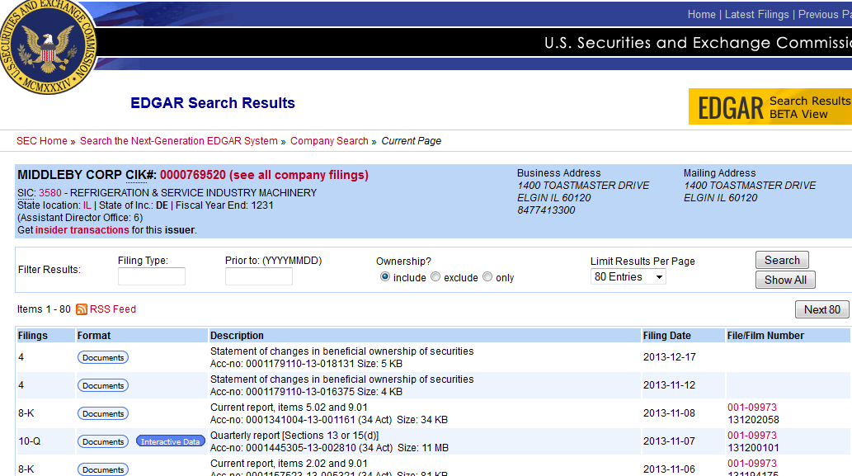

See FirstResult.txt where a copy of the html is stored.
Search for the <table class="tableFile2" summary="Results"> and go through the rows to get to the urls for each filing.
The rows contain the Filings (form type), Format, Description, and Filing Date

The Format field contains a url like below for each filing.
“/Archives/edgar/data/769520/000117911013018131/0001179110-13-018131-index.htm”

Append http://www.sec.gov to each one to get the actual url
http://www.sec.gov/Archives/edgar/data/769520/000117911013018131/0001179110-13-018131-index.htm

going to the url will bring you to a page like below.

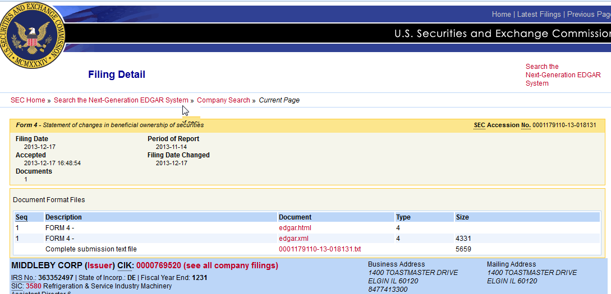
See SecondResult.txt for reference.
That file will contain a table <table class="tableFile" summary="Document Format Files">
There will be a url for under edgar.html

<td scope="row"><a href="/Archives/edgar/data/769520/000117911013018131/xslF345X03/edgar.xml">edgar.html</a></td>

prepend www.sec.gov to the url will get
http://www.sec.gov/Archives/edgar/data/769520/000117911013018131/xslF345X03/edgar.xml

following that link will get you to the filing document. See below.
(See ThirdResult.txt)

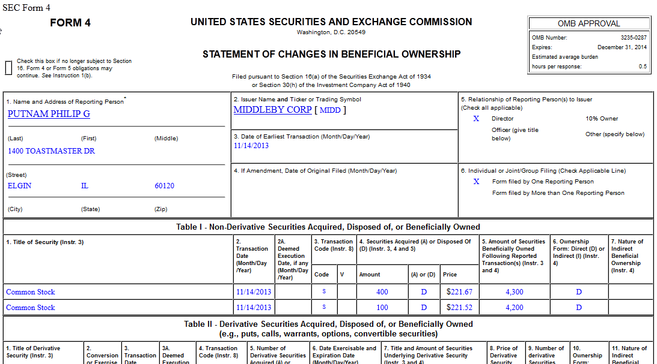

Store these filings in a database table and use Telerik Html control to rerender them

